Implemented Karpenter on Amazon EKS using EC2NodeClass and NodePools. Validated dynamic node provisioning and consolidation by scaling workloads up and down, observing automatic EC2 node creation, node registration, workload scheduling, and node deprovisioning.
Implemented Karpenter autoscaling and validated node lifecycle
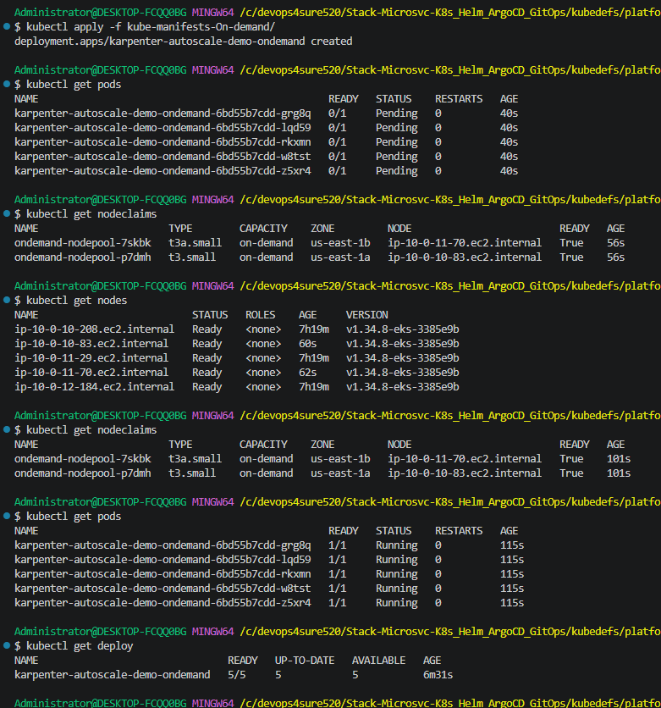
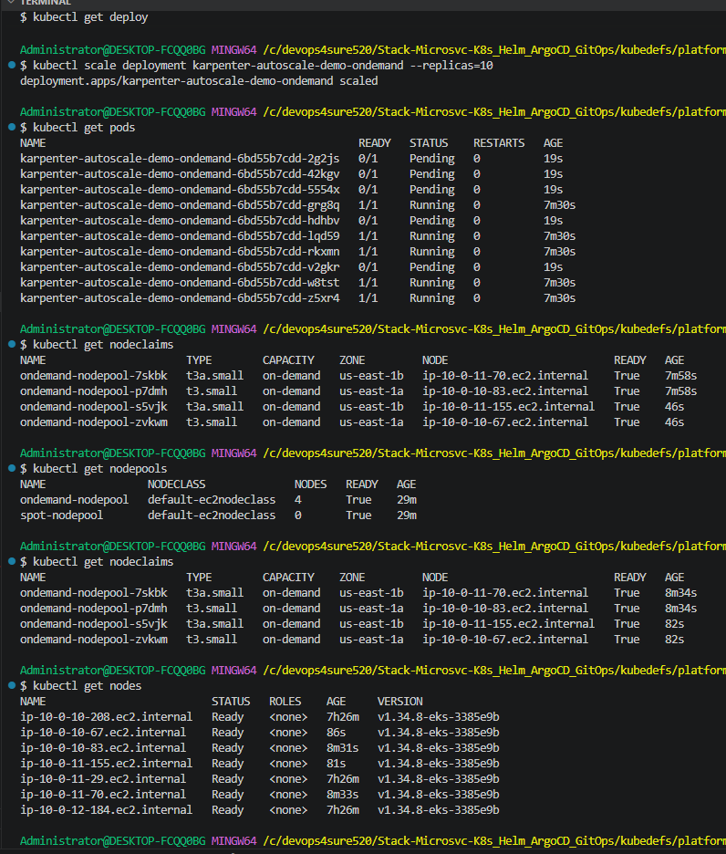
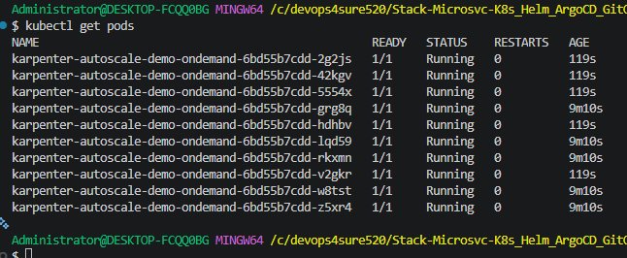
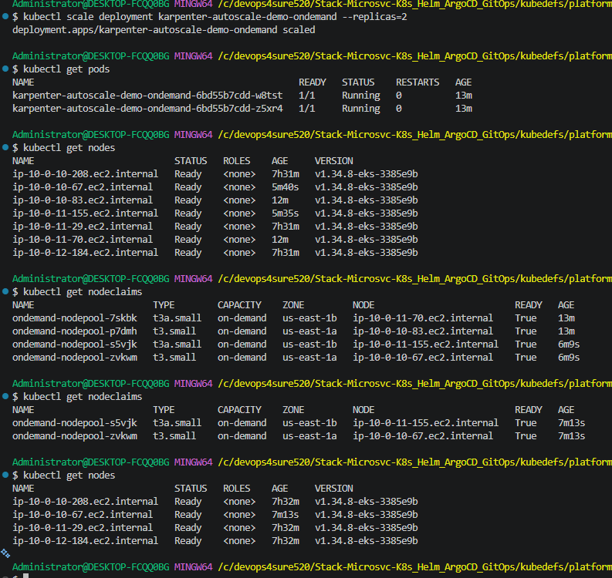
Administrator@DESKTOP-FCQQ0BG MINGW64 /c/devops4sure520/Stack-Microsvc-K8s_Helm_ArgoCD_GitOps/kubedefs/platform/KARPENTER_k8s-manifests (main)
$ ls
01_ec2nodeclass.yaml 02_nodepool_ondemand.yaml 03_nodepool_spot.yaml 17_02_Karpenter_On-demand_Instances/ 17_03_Karpenter_Spot_Instances/ 17_04_Karpenter_Spot_Interruption_Handling/

Administrator@DESKTOP-FCQQ0BG MINGW64 /c/devops4sure520/Stack-Microsvc-K8s_Helm_ArgoCD_GitOps/kubedefs/platform/KARPENTER_k8s-manifests (main)
$ kubectl get pods
No resources found in default namespace.

Administrator@DESKTOP-FCQQ0BG MINGW64 /c/devops4sure520/Stack-Microsvc-K8s_Helm_ArgoCD_GitOps/kubedefs/platform/KARPENTER_k8s-manifests (main)
$ kubectl apply -f 01_ec2nodeclass.yaml
ec2nodeclass.karpenter.k8s.aws/default-ec2nodeclass created

Administrator@DESKTOP-FCQQ0BG MINGW64 /c/devops4sure520/Stack-Microsvc-K8s_Helm_ArgoCD_GitOps/kubedefs/platform/KARPENTER_k8s-manifests (main)
$ kubectl apply -f 02_nodepool_ondemand.yaml
nodepool.karpenter.sh/ondemand-nodepool created

Administrator@DESKTOP-FCQQ0BG MINGW64 /c/devops4sure520/Stack-Microsvc-K8s_Helm_ArgoCD_GitOps/kubedefs/platform/KARPENTER_k8s-manifests (main)
$ kubectl apply -f 03_nodepool_spot.yaml
nodepool.karpenter.sh/spot-nodepool created

Administrator@DESKTOP-FCQQ0BG MINGW64 /c/devops4sure520/Stack-Microsvc-K8s_Helm_ArgoCD_GitOps/kubedefs/platform/KARPENTER_k8s-manifests (main)
$ kubectl get nodes
NAME STATUS ROLES AGE VERSION
ip-10-0-10-208.ec2.internal Ready <none> 22h v1.34.8-eks-3385e9b
ip-10-0-11-29.ec2.internal Ready <none> 22h v1.34.8-eks-3385e9b
ip-10-0-12-184.ec2.internal Ready <none> 22h v1.34.8-eks-3385e9b

Administrator@DESKTOP-FCQQ0BG MINGW64 /c/devops4sure520/Stack-Microsvc-K8s_Helm_ArgoCD_GitOps/kubedefs/platform/KARPENTER_k8s-manifests (main)
$ kubectl get nodeclaims
No resources found

Administrator@DESKTOP-FCQQ0BG MINGW64 /c/devops4sure520/Stack-Microsvc-K8s_Helm_ArgoCD_GitOps/kubedefs/platform/KARPENTER_k8s-manifests (main)
$ kubectl get ec2nodeclass
NAME READY AGE
default-ec2nodeclass True 94s

Administrator@DESKTOP-FCQQ0BG MINGW64 /c/devops4sure520/Stack-Microsvc-K8s_Helm_ArgoCD_GitOps/kubedefs/platform/KARPENTER_k8s-manifests (main)
$ kubectl describe ec2nodeclass default-ec2nodeclass
Name: default-ec2nodeclass
Namespace:
Labels: <none>
Annotations: karpenter.k8s.aws/ec2nodeclass-hash: 12584748436141608854
karpenter.k8s.aws/ec2nodeclass-hash-version: v4
API Version: karpenter.k8s.aws/v1
Kind: EC2NodeClass
Metadata:
Creation Timestamp: 2026-05-30T16:23:47Z
Finalizers:
karpenter.k8s.aws/termination
Generation: 1
Resource Version: 1846182
UID: 4c01fc16-b66a-4e57-970d-e3e82e283660
Spec:
Ami Family: AL2023
Ami Selector Terms:
Alias: al2023@latest
Block Device Mappings:
Device Name: /dev/xvda
Ebs:
Delete On Termination: true
Encrypted: true
Volume Size: 20Gi
Volume Type: gp3
Metadata Options:
Http Endpoint: enabled
httpProtocolIPv6: disabled
Http Put Response Hop Limit: 2
Http Tokens: required
Role: arn:aws:iam::788143860357:role/retail-dev-karpenter-node-role
Security Group Selector Terms:
Tags:
kubernetes.io/cluster/retail-dev-platform-eks: owned
Subnet Selector Terms:
Tags:
kubernetes.io/cluster/retail-dev-platform-eks: owned
kubernetes.io/role/internal-elb: 1
Tags:
karpenter.sh/discovery: retail-dev-platform-eks
Status:
Amis:
Id: ami-02085840809106853
Name: amazon-eks-node-al2023-arm64-nvidia-1.34-v20260527
Requirements:
Key: kubernetes.io/arch
Operator: In
Values:
arm64
Key: karpenter.k8s.aws/instance-gpu-count
Operator: Exists
Id: ami-05852713546f96759
Name: amazon-eks-node-al2023-x86_64-neuron-1.34-v20260527
Requirements:
Key: kubernetes.io/arch
Operator: In
Values:
amd64
Key: karpenter.k8s.aws/instance-accelerator-count
Operator: Exists
Id: ami-0968093d565e4a7b6
Name: amazon-eks-node-al2023-x86_64-nvidia-1.34-v20260527
Requirements:
Key: kubernetes.io/arch
Operator: In
Values:
amd64
Key: karpenter.k8s.aws/instance-gpu-count
Operator: Exists
Id: ami-03edb027ad1105d55
Name: amazon-eks-node-al2023-arm64-standard-1.34-v20260527
Requirements:
Key: kubernetes.io/arch
Operator: In
Values:
arm64
Key: karpenter.k8s.aws/instance-gpu-count
Operator: DoesNotExist
Key: karpenter.k8s.aws/instance-accelerator-count
Operator: DoesNotExist
Id: ami-08b85019512f9b727
Name: amazon-eks-node-al2023-x86_64-standard-1.34-v20260527
Requirements:
Key: kubernetes.io/arch
Operator: In
Values:
amd64
Key: karpenter.k8s.aws/instance-gpu-count
Operator: DoesNotExist
Key: karpenter.k8s.aws/instance-accelerator-count
Operator: DoesNotExist
Conditions:
Last Transition Time: 2026-05-30T16:23:48Z
Message:
Observed Generation: 1
Reason: AMIsReady
Status: True
Type: AMIsReady
Last Transition Time: 2026-05-30T16:23:48Z
Message:
Observed Generation: 1
Reason: CapacityReservationsReady
Status: True
Type: CapacityReservationsReady
Last Transition Time: 2026-05-30T16:23:48Z
Message:
Observed Generation: 1
Reason: SubnetsReady
Status: True
Type: SubnetsReady
Last Transition Time: 2026-05-30T16:23:48Z
Message:
Observed Generation: 1
Reason: SecurityGroupsReady
Status: True
Type: SecurityGroupsReady
Last Transition Time: 2026-05-30T16:23:48Z
Message:
Observed Generation: 1
Reason: InstanceProfileReady
Status: True
Type: InstanceProfileReady
Last Transition Time: 2026-05-30T16:23:55Z
Message:
Observed Generation: 1
Reason: ValidationSucceeded
Status: True
Type: ValidationSucceeded
Last Transition Time: 2026-05-30T16:23:55Z
Message:
Observed Generation: 1
Reason: Ready
Status: True
Type: Ready
Instance Profile: retail-dev-platform-eks_11040119419547027872
Security Groups:
Id: sg-014156d93a8007372
Name: eks-cluster-sg-retail-dev-platform-eks-1345947019
Subnets:
Id: subnet-0cf4f2754bb68b963
Zone: us-east-1a
Zone ID: use1-az1
Id: subnet-0b953a2b8de791a45
Zone: us-east-1c
Zone ID: use1-az4
Id: subnet-0c0bdbf4b6ee51855
Zone: us-east-1b
Zone ID: use1-az2
Events:
Type Reason Age From Message
---- ------ ---- ---- -------
Normal AMIsReady 2m11s karpenter Status condition transitioned, Type: AMIsReady, Status: Unknown -> True, Reason: AMIsReady
Normal CapacityReservationsReady 2m11s karpenter Status condition transitioned, Type: CapacityReservationsReady, Status: Unknown -> True, Reason: CapacityReservationsReady
Normal SubnetsReady 2m11s karpenter Status condition transitioned, Type: SubnetsReady, Status: Unknown -> True, Reason: SubnetsReady
Normal SecurityGroupsReady 2m11s karpenter Status condition transitioned, Type: SecurityGroupsReady, Status: Unknown -> True, Reason: SecurityGroupsReady
Normal InstanceProfileReady 2m11s karpenter Status condition transitioned, Type: InstanceProfileReady, Status: Unknown -> True, Reason: InstanceProfileReady
Normal ValidationSucceeded 2m5s karpenter Status condition transitioned, Type: ValidationSucceeded, Status: Unknown -> True, Reason: ValidationSucceeded
Normal Ready 2m5s karpenter Status condition transitioned, Type: Ready, Status: Unknown -> True, Reason: Ready

Administrator@DESKTOP-FCQQ0BG MINGW64 /c/devops4sure520/Stack-Microsvc-K8s_Helm_ArgoCD_GitOps/kubedefs/platform/KARPENTER_k8s-manifests (main)
$ kubectl get nodepools
NAME NODECLASS NODES READY AGE
ondemand-nodepool default-ec2nodeclass 0 True 2m56s
spot-nodepool default-ec2nodeclass 0 True 2m32s

Administrator@DESKTOP-FCQQ0BG MINGW64 /c/devops4sure520/Stack-Microsvc-K8s_Helm_ArgoCD_GitOps/kubedefs/platform/KARPENTER_k8s-manifests (main)
$ ls
01_ec2nodeclass.yaml 02_nodepool_ondemand.yaml 03_nodepool_spot.yaml 17_02_Karpenter_On-demand_Instances/ 17_03_Karpenter_Spot_Instances/ 17_04_Karpenter_Spot_Interruption_Handling/

Administrator@DESKTOP-FCQQ0BG MINGW64 /c/devops4sure520/Stack-Microsvc-K8s_Helm_ArgoCD_GitOps/kubedefs/platform/KARPENTER_k8s-manifests (main)
$ cd 17_02_Karpenter_On-demand_Instances/

Administrator@DESKTOP-FCQQ0BG MINGW64 /c/devops4sure520/Stack-Microsvc-K8s_Helm_ArgoCD_GitOps/kubedefs/platform/KARPENTER_k8s-manifests/17_02_Karpenter_On-demand_Instances (main)
$ ls
kube-manifests-On-demand/ README.md

Administrator@DESKTOP-FCQQ0BG MINGW64 /c/devops4sure520/Stack-Microsvc-K8s_Helm_ArgoCD_GitOps/kubedefs/platform/KARPENTER_k8s-manifests/17_02_Karpenter_On-demand_Instances (main)
$ kubectl apply -f kube-manifests-On-demand/
deployment.apps/karpenter-autoscale-demo-ondemand created

Administrator@DESKTOP-FCQQ0BG MINGW64 /c/devops4sure520/Stack-Microsvc-K8s_Helm_ArgoCD_GitOps/kubedefs/platform/KARPENTER_k8s-manifests/17_02_Karpenter_On-demand_Instances (main)
$ kubectl get pods
NAME READY STATUS RESTARTS AGE
karpenter-autoscale-demo-ondemand-6bd55b7cdd-8xf9h 0/1 Pending 0 14s
karpenter-autoscale-demo-ondemand-6bd55b7cdd-nwn6t 0/1 Pending 0 14s
karpenter-autoscale-demo-ondemand-6bd55b7cdd-rlz62 0/1 Pending 0 14s
karpenter-autoscale-demo-ondemand-6bd55b7cdd-zn8sv 0/1 Pending 0 14s
karpenter-autoscale-demo-ondemand-6bd55b7cdd-ztl96 0/1 Pending 0 14s

Administrator@DESKTOP-FCQQ0BG MINGW64 /c/devops4sure520/Stack-Microsvc-K8s_Helm_ArgoCD_GitOps/kubedefs/platform/KARPENTER_k8s-manifests/17_02_Karpenter_On-demand_Instances (main)
$ kubectl get pods
NAME READY STATUS RESTARTS AGE
karpenter-autoscale-demo-ondemand-6bd55b7cdd-8xf9h 0/1 Pending 0 25s
karpenter-autoscale-demo-ondemand-6bd55b7cdd-nwn6t 0/1 Pending 0 25s
karpenter-autoscale-demo-ondemand-6bd55b7cdd-rlz62 0/1 Pending 0 25s
karpenter-autoscale-demo-ondemand-6bd55b7cdd-zn8sv 0/1 Pending 0 25s
karpenter-autoscale-demo-ondemand-6bd55b7cdd-ztl96 0/1 Pending 0 25s

Administrator@DESKTOP-FCQQ0BG MINGW64 /c/devops4sure520/Stack-Microsvc-K8s_Helm_ArgoCD_GitOps/kubedefs/platform/KARPENTER_k8s-manifests/17_02_Karpenter_On-demand_Instances (main)
$ kubectl get pods
NAME READY STATUS RESTARTS AGE
karpenter-autoscale-demo-ondemand-6bd55b7cdd-8xf9h 1/1 Running 0 89s
karpenter-autoscale-demo-ondemand-6bd55b7cdd-nwn6t 1/1 Running 0 89s
karpenter-autoscale-demo-ondemand-6bd55b7cdd-rlz62 1/1 Running 0 89s
karpenter-autoscale-demo-ondemand-6bd55b7cdd-zn8sv 1/1 Running 0 89s
karpenter-autoscale-demo-ondemand-6bd55b7cdd-ztl96 1/1 Running 0 89s

Administrator@DESKTOP-FCQQ0BG MINGW64 /c/devops4sure520/Stack-Microsvc-K8s_Helm_ArgoCD_GitOps/kubedefs/platform/KARPENTER_k8s-manifests/17_02_Karpenter_On-demand_Instances (main)
$ kubectl get nodecliams
error: the server doesn't have a resource type "nodecliams"

Administrator@DESKTOP-FCQQ0BG MINGW64 /c/devops4sure520/Stack-Microsvc-K8s_Helm_ArgoCD_GitOps/kubedefs/platform/KARPENTER_k8s-manifests/17_02_Karpenter_On-demand_Instances (main)
$ kubectl get nodeclaims
NAME TYPE CAPACITY ZONE NODE READY AGE
ondemand-nodepool-7nnsp t3.small on-demand us-east-1b ip-10-0-11-168.ec2.internal True 3m49s
ondemand-nodepool-xxffv t3a.small on-demand us-east-1a ip-10-0-10-112.ec2.internal True 3m49s

Administrator@DESKTOP-FCQQ0BG MINGW64 /c/devops4sure520/Stack-Microsvc-K8s_Helm_ArgoCD_GitOps/kubedefs/platform/KARPENTER_k8s-manifests/17_02_Karpenter_On-demand_Instances (main)
$ kubectl get nodes
NAME STATUS ROLES AGE VERSION
ip-10-0-10-112.ec2.internal Ready <none> 5m47s v1.34.8-eks-3385e9b
ip-10-0-10-208.ec2.internal Ready <none> 22h v1.34.8-eks-3385e9b
ip-10-0-11-168.ec2.internal Ready <none> 5m47s v1.34.8-eks-3385e9b
ip-10-0-11-29.ec2.internal Ready <none> 22h v1.34.8-eks-3385e9b
ip-10-0-12-184.ec2.internal Ready <none> 22h v1.34.8-eks-3385e9b

Administrator@DESKTOP-FCQQ0BG MINGW64 /c/devops4sure520/Stack-Microsvc-K8s_Helm_ArgoCD_GitOps/kubedefs/platform/KARPENTER_k8s-manifests/17_02_Karpenter_On-demand_Instances (main)
$

Administrator@DESKTOP-FCQQ0BG MINGW64 /c/devops4sure520/Stack-Microsvc-K8s_Helm_ArgoCD_GitOps/kubedefs/platform/KARPENTER_k8s-manifests/17_02_Karpenter_On-demand_Instances (main)
$ kubectl get deploy
NAME READY UP-TO-DATE AVAILABLE AGE
karpenter-autoscale-demo-ondemand 5/5 5 5 8m40s

Administrator@DESKTOP-FCQQ0BG MINGW64 /c/devops4sure520/Stack-Microsvc-K8s_Helm_ArgoCD_GitOps/kubedefs/platform/KARPENTER_k8s-manifests/17_02_Karpenter_On-demand_Instances (main)
$ kubectl scale deployment karpenter-autoscale-demo-ondemand --replicas=10
deployment.apps/karpenter-autoscale-demo-ondemand scaled

Administrator@DESKTOP-FCQQ0BG MINGW64 /c/devops4sure520/Stack-Microsvc-K8s_Helm_ArgoCD_GitOps/kubedefs/platform/KARPENTER_k8s-manifests/17_02_Karpenter_On-demand_Instances (main)
$ kubectl get pods
NAME READY STATUS RESTARTS AGE
karpenter-autoscale-demo-ondemand-6bd55b7cdd-8xf9h 1/1 Running 0 9m19s
karpenter-autoscale-demo-ondemand-6bd55b7cdd-fxrmb 0/1 Pending 0 13s
karpenter-autoscale-demo-ondemand-6bd55b7cdd-n5f89 0/1 Pending 0 13s
karpenter-autoscale-demo-ondemand-6bd55b7cdd-nwn6t 1/1 Running 0 9m19s
karpenter-autoscale-demo-ondemand-6bd55b7cdd-pw8hz 0/1 Pending 0 13s
karpenter-autoscale-demo-ondemand-6bd55b7cdd-rcjjz 0/1 Pending 0 13s
karpenter-autoscale-demo-ondemand-6bd55b7cdd-rlz62 1/1 Running 0 9m19s
karpenter-autoscale-demo-ondemand-6bd55b7cdd-t582r 0/1 Pending 0 13s
karpenter-autoscale-demo-ondemand-6bd55b7cdd-zn8sv 1/1 Running 0 9m19s
karpenter-autoscale-demo-ondemand-6bd55b7cdd-ztl96 1/1 Running 0 9m19s

Administrator@DESKTOP-FCQQ0BG MINGW64 /c/devops4sure520/Stack-Microsvc-K8s_Helm_ArgoCD_GitOps/kubedefs/platform/KARPENTER_k8s-manifests/17_02_Karpenter_On-demand_Instances (main)
$ kubectl get nodeclaims
NAME TYPE CAPACITY ZONE NODE READY AGE
ondemand-nodepool-4clgz t3.small on-demand us-east-1a Unknown 22s
ondemand-nodepool-7nnsp t3.small on-demand us-east-1b ip-10-0-11-168.ec2.internal True 9m28s
ondemand-nodepool-srzdr t3a.small on-demand us-east-1b Unknown 22s
ondemand-nodepool-xxffv t3a.small on-demand us-east-1a ip-10-0-10-112.ec2.internal True 9m28s

Administrator@DESKTOP-FCQQ0BG MINGW64 /c/devops4sure520/Stack-Microsvc-K8s_Helm_ArgoCD_GitOps/kubedefs/platform/KARPENTER_k8s-manifests/17_02_Karpenter_On-demand_Instances (main)
$ kubectl get nodeclaims
NAME TYPE CAPACITY ZONE NODE READY AGE
ondemand-nodepool-4clgz t3.small on-demand us-east-1a ip-10-0-10-158.ec2.internal True 43s
ondemand-nodepool-7nnsp t3.small on-demand us-east-1b ip-10-0-11-168.ec2.internal True 9m49s
ondemand-nodepool-srzdr t3a.small on-demand us-east-1b ip-10-0-11-78.ec2.internal True 43s
ondemand-nodepool-xxffv t3a.small on-demand us-east-1a ip-10-0-10-112.ec2.internal True 9m49s

Administrator@DESKTOP-FCQQ0BG MINGW64 /c/devops4sure520/Stack-Microsvc-K8s_Helm_ArgoCD_GitOps/kubedefs/platform/KARPENTER_k8s-manifests/17_02_Karpenter_On-demand_Instances (main)
$ kubectl get nodepools
NAME NODECLASS NODES READY AGE
ondemand-nodepool default-ec2nodeclass 4 True 15m
spot-nodepool default-ec2nodeclass 0 True 15m

Administrator@DESKTOP-FCQQ0BG MINGW64 /c/devops4sure520/Stack-Microsvc-K8s_Helm_ArgoCD_GitOps/kubedefs/platform/KARPENTER_k8s-manifests/17_02_Karpenter_On-demand_Instances (main)
$ kubectl get nodes
NAME STATUS ROLES AGE VERSION
ip-10-0-10-112.ec2.internal Ready <none> 9m54s v1.34.8-eks-3385e9b
ip-10-0-10-158.ec2.internal Ready <none> 49s v1.34.8-eks-3385e9b
ip-10-0-10-208.ec2.internal Ready <none> 22h v1.34.8-eks-3385e9b
ip-10-0-11-168.ec2.internal Ready <none> 9m54s v1.34.8-eks-3385e9b
ip-10-0-11-29.ec2.internal Ready <none> 22h v1.34.8-eks-3385e9b
ip-10-0-11-78.ec2.internal Ready <none> 46s v1.34.8-eks-3385e9b
ip-10-0-12-184.ec2.internal Ready <none> 22h v1.34.8-eks-3385e9b

Administrator@DESKTOP-FCQQ0BG MINGW64 /c/devops4sure520/Stack-Microsvc-K8s_Helm_ArgoCD_GitOps/kubedefs/platform/KARPENTER_k8s-manifests/17_02_Karpenter_On-demand_Instances (main)
$ kubectl get pods
NAME READY STATUS RESTARTS AGE
karpenter-autoscale-demo-ondemand-6bd55b7cdd-8xf9h 1/1 Running 0 10m
karpenter-autoscale-demo-ondemand-6bd55b7cdd-fxrmb 1/1 Running 0 91s
karpenter-autoscale-demo-ondemand-6bd55b7cdd-n5f89 1/1 Running 0 91s
karpenter-autoscale-demo-ondemand-6bd55b7cdd-nwn6t 1/1 Running 0 10m
karpenter-autoscale-demo-ondemand-6bd55b7cdd-pw8hz 1/1 Running 0 91s
karpenter-autoscale-demo-ondemand-6bd55b7cdd-rcjjz 1/1 Running 0 91s
karpenter-autoscale-demo-ondemand-6bd55b7cdd-rlz62 1/1 Running 0 10m
karpenter-autoscale-demo-ondemand-6bd55b7cdd-t582r 1/1 Running 0 91s
karpenter-autoscale-demo-ondemand-6bd55b7cdd-zn8sv 1/1 Running 0 10m
karpenter-autoscale-demo-ondemand-6bd55b7cdd-ztl96 1/1 Running 0 10m

Administrator@DESKTOP-FCQQ0BG MINGW64 /c/devops4sure520/Stack-Microsvc-K8s_Helm_ArgoCD_GitOps/kubedefs/platform/KARPENTER_k8s-manifests/17_02_Karpenter_On-demand_Instances (main)
$ kubectl scale deployment karpenter-autoscale-demo-ondemand --replicas=2
deployment.apps/karpenter-autoscale-demo-ondemand scaled

Administrator@DESKTOP-FCQQ0BG MINGW64 /c/devops4sure520/Stack-Microsvc-K8s_Helm_ArgoCD_GitOps/kubedefs/platform/KARPENTER_k8s-manifests/17_02_Karpenter_On-demand_Instances (main)
$ kubectl get pods
NAME READY STATUS RESTARTS AGE
karpenter-autoscale-demo-ondemand-6bd55b7cdd-nwn6t 1/1 Running 0 11m
karpenter-autoscale-demo-ondemand-6bd55b7cdd-zn8sv 1/1 Running 0 11m

Administrator@DESKTOP-FCQQ0BG MINGW64 /c/devops4sure520/Stack-Microsvc-K8s_Helm_ArgoCD_GitOps/kubedefs/platform/KARPENTER_k8s-manifests/17_02_Karpenter_On-demand_Instances (main)
$ kubectl get nodeclaims
NAME TYPE CAPACITY ZONE NODE READY AGE
ondemand-nodepool-4clgz t3.small on-demand us-east-1a ip-10-0-10-158.ec2.internal True 2m22s
ondemand-nodepool-7nnsp t3.small on-demand us-east-1b ip-10-0-11-168.ec2.internal True 11m
ondemand-nodepool-srzdr t3a.small on-demand us-east-1b ip-10-0-11-78.ec2.internal True 2m22s
ondemand-nodepool-xxffv t3a.small on-demand us-east-1a ip-10-0-10-112.ec2.internal True 11m

Administrator@DESKTOP-FCQQ0BG MINGW64 /c/devops4sure520/Stack-Microsvc-K8s_Helm_ArgoCD_GitOps/kubedefs/platform/KARPENTER_k8s-manifests/17_02_Karpenter_On-demand_Instances (main)
$ kubectl get nodeclaims
NAME TYPE CAPACITY ZONE NODE READY AGE
ondemand-nodepool-4clgz t3.small on-demand us-east-1a ip-10-0-10-158.ec2.internal True 3m6s
ondemand-nodepool-7nnsp t3.small on-demand us-east-1b ip-10-0-11-168.ec2.internal True 12m
ondemand-nodepool-srzdr t3a.small on-demand us-east-1b ip-10-0-11-78.ec2.internal True 3m6s

Administrator@DESKTOP-FCQQ0BG MINGW64 /c/devops4sure520/Stack-Microsvc-K8s_Helm_ArgoCD_GitOps/kubedefs/platform/KARPENTER_k8s-manifests/17_02_Karpenter_On-demand_Instances (main)
$ kubectl get nodeclaims
NAME TYPE CAPACITY ZONE NODE READY AGE
ondemand-nodepool-4clgz t3.small on-demand us-east-1a ip-10-0-10-158.ec2.internal True 3m23s
ondemand-nodepool-srzdr t3a.small on-demand us-east-1b ip-10-0-11-78.ec2.internal True 3m23s

Administrator@DESKTOP-FCQQ0BG MINGW64 /c/devops4sure520/Stack-Microsvc-K8s_Helm_ArgoCD_GitOps/kubedefs/platform/KARPENTER_k8s-manifests/17_02_Karpenter_On-demand_Instances (main)
$ kubectl get nodeclaims
NAME TYPE CAPACITY ZONE NODE READY AGE
ondemand-nodepool-4clgz t3.small on-demand us-east-1a ip-10-0-10-158.ec2.internal True 4m11s
ondemand-nodepool-v85pq t3a.small on-demand us-east-1b Unknown 19s

Administrator@DESKTOP-FCQQ0BG MINGW64 /c/devops4sure520/Stack-Microsvc-K8s_Helm_ArgoCD_GitOps/kubedefs/platform/KARPENTER_k8s-manifests/17_02_Karpenter_On-demand_Instances (main)
$ kubectl get nodeclaims
NAME TYPE CAPACITY ZONE NODE READY AGE
ondemand-nodepool-4clgz t3.small on-demand us-east-1a ip-10-0-10-158.ec2.internal True 4m43s
ondemand-nodepool-v85pq t3a.small on-demand us-east-1b ip-10-0-11-241.ec2.internal True 51s

Administrator@DESKTOP-FCQQ0BG MINGW64 /c/devops4sure520/Stack-Microsvc-K8s_Helm_ArgoCD_GitOps/kubedefs/platform/KARPENTER_k8s-manifests/17_02_Karpenter_On-demand_Instances (main)
$ ls
kube-manifests-On-demand/ README.md

Administrator@DESKTOP-FCQQ0BG MINGW64 /c/devops4sure520/Stack-Microsvc-K8s_Helm_ArgoCD_GitOps/kubedefs/platform/KARPENTER_k8s-manifests/17_02_Karpenter_On-demand_Instances (main)
$ kubectl delete -f kube-manifests-On-demand/
deployment.apps "karpenter-autoscale-demo-ondemand" deleted from default namespace

Administrator@DESKTOP-FCQQ0BG MINGW64 /c/devops4sure520/Stack-Microsvc-K8s_Helm_ArgoCD_GitOps/kubedefs/platform/KARPENTER_k8s-manifests/17_02_Karpenter_On-demand_Instances (main)
$ kubectl get nodeclaims
NAME TYPE CAPACITY ZONE NODE READY AGE
ondemand-nodepool-v85pq t3a.small on-demand us-east-1b ip-10-0-11-241.ec2.internal True 84s

Administrator@DESKTOP-FCQQ0BG MINGW64 /c/devops4sure520/Stack-Microsvc-K8s_Helm_ArgoCD_GitOps/kubedefs/platform/KARPENTER_k8s-manifests/17_02_Karpenter_On-demand_Instances (main)
$ kubectl get pods
No resources found in default namespace.

Administrator@DESKTOP-FCQQ0BG MINGW64 /c/devops4sure520/Stack-Microsvc-K8s_Helm_ArgoCD_GitOps/kubedefs/platform/KARPENTER_k8s-manifests/17_02_Karpenter_On-demand_Instances (main)
$ kubectl get nodeclaims
NAME TYPE CAPACITY ZONE NODE READY AGE
ondemand-nodepool-v85pq t3a.small on-demand us-east-1b ip-10-0-11-241.ec2.internal True 109s

Administrator@DESKTOP-FCQQ0BG MINGW64 /c/devops4sure520/Stack-Microsvc-K8s_Helm_ArgoCD_GitOps/kubedefs/platform/KARPENTER_k8s-manifests/17_02_Karpenter_On-demand_Instances (main)
$ kubectl get nodes
NAME STATUS ROLES AGE VERSION
ip-10-0-10-208.ec2.internal Ready <none> 22h v1.34.8-eks-3385e9b
ip-10-0-11-241.ec2.internal NotReady <none> 99s v1.34.8-eks-3385e9b
ip-10-0-11-29.ec2.internal Ready <none> 22h v1.34.8-eks-3385e9b
ip-10-0-12-184.ec2.internal Ready <none> 22h v1.34.8-eks-3385e9b

Administrator@DESKTOP-FCQQ0BG MINGW64 /c/devops4sure520/Stack-Microsvc-K8s_Helm_ArgoCD_GitOps/kubedefs/platform/KARPENTER_k8s-manifests/17_02_Karpenter_On-demand_Instances (main)
$ kubectl get nodeclaims
NAME TYPE CAPACITY ZONE NODE READY AGE
ondemand-nodepool-v85pq t3a.small on-demand us-east-1b ip-10-0-11-241.ec2.internal True 2m16s

Administrator@DESKTOP-FCQQ0BG MINGW64 /c/devops4sure520/Stack-Microsvc-K8s_Helm_ArgoCD_GitOps/kubedefs/platform/KARPENTER_k8s-manifests/17_02_Karpenter_On-demand_Instances (main)
$ kubectl get nodes
NAME STATUS ROLES AGE VERSION
ip-10-0-10-208.ec2.internal Ready <none> 22h v1.34.8-eks-3385e9b
ip-10-0-11-241.ec2.internal NotReady <none> 2m5s v1.34.8-eks-3385e9b
ip-10-0-11-29.ec2.internal Ready <none> 22h v1.34.8-eks-3385e9b
ip-10-0-12-184.ec2.internal Ready <none> 22h v1.34.8-eks-3385e9b

Administrator@DESKTOP-FCQQ0BG MINGW64 /c/devops4sure520/Stack-Microsvc-K8s_Helm_ArgoCD_GitOps/kubedefs/platform/KARPENTER_k8s-manifests/17_02_Karpenter_On-demand_Instances (main)
$

Administrator@DESKTOP-FCQQ0BG MINGW64 /c/devops4sure520/Stack-Microsvc-K8s_Helm_ArgoCD_GitOps/kubedefs/platform/KARPENTER_k8s-manifests/17_02_Karpenter_On-demand_Instances (main)
$ kubectl get nodes
NAME STATUS ROLES AGE VERSION
ip-10-0-10-208.ec2.internal Ready <none> 22h v1.34.8-eks-3385e9b
ip-10-0-11-29.ec2.internal Ready <none> 22h v1.34.8-eks-3385e9b
ip-10-0-12-184.ec2.internal Ready <none> 22h v1.34.8-eks-3385e9b

Administrator@DESKTOP-FCQQ0BG MINGW64 /c/devops4sure520/Stack-Microsvc-K8s_Helm_ArgoCD_GitOps/kubedefs/platform/KARPENTER_k8s-manifests/17_02_Karpenter_On-demand_Instances (main)
$ kubectl get nodeclaims
No resources found

Administrator@DESKTOP-FCQQ0BG MINGW64 /c/devops4sure520/Stack-Microsvc-K8s_Helm_ArgoCD_GitOps/kubedefs/platform/KARPENTER_k8s-manifests/17_02_Karpenter_On-demand_Instances (main)
$

